1. **Movie Should have multiple Media ( Image or Video)**

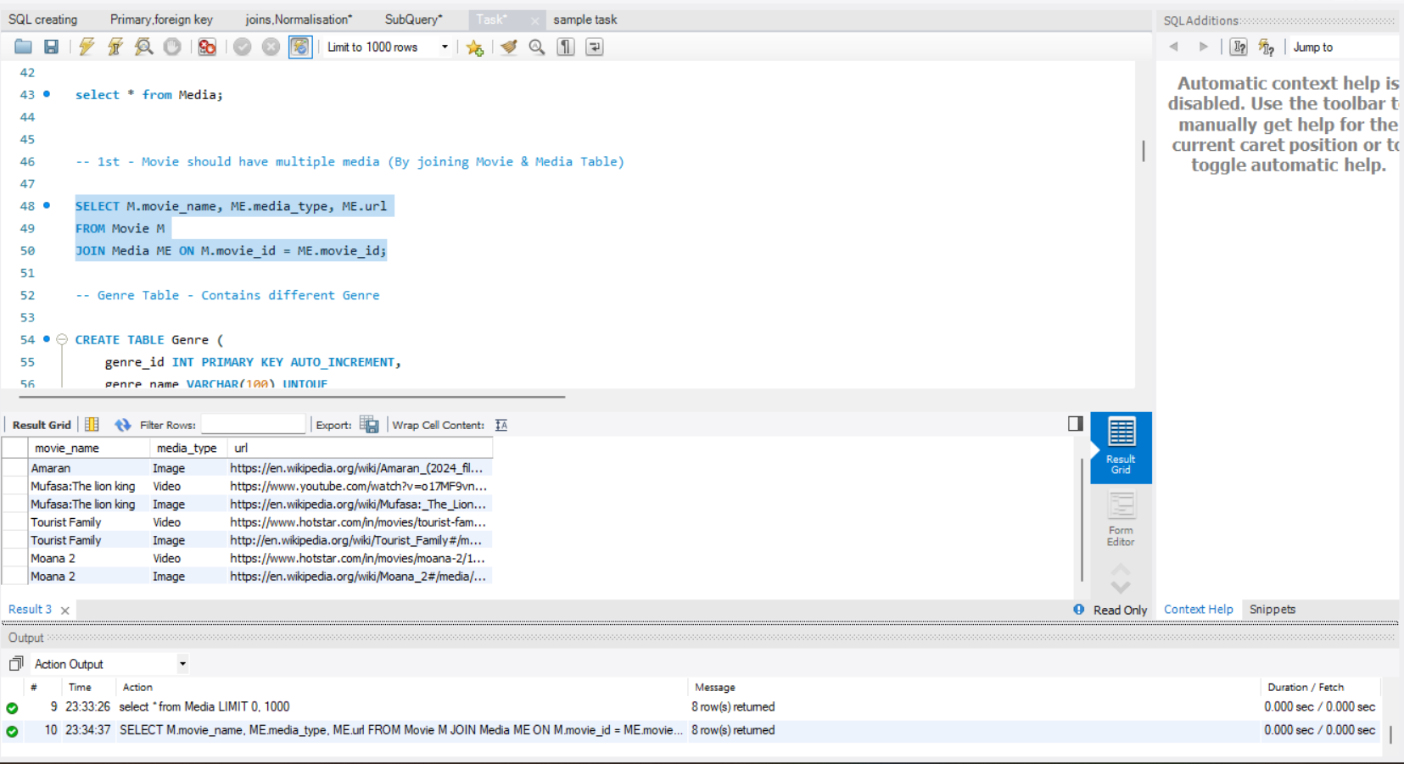

1. **Movie can belongs to multiple genre**.

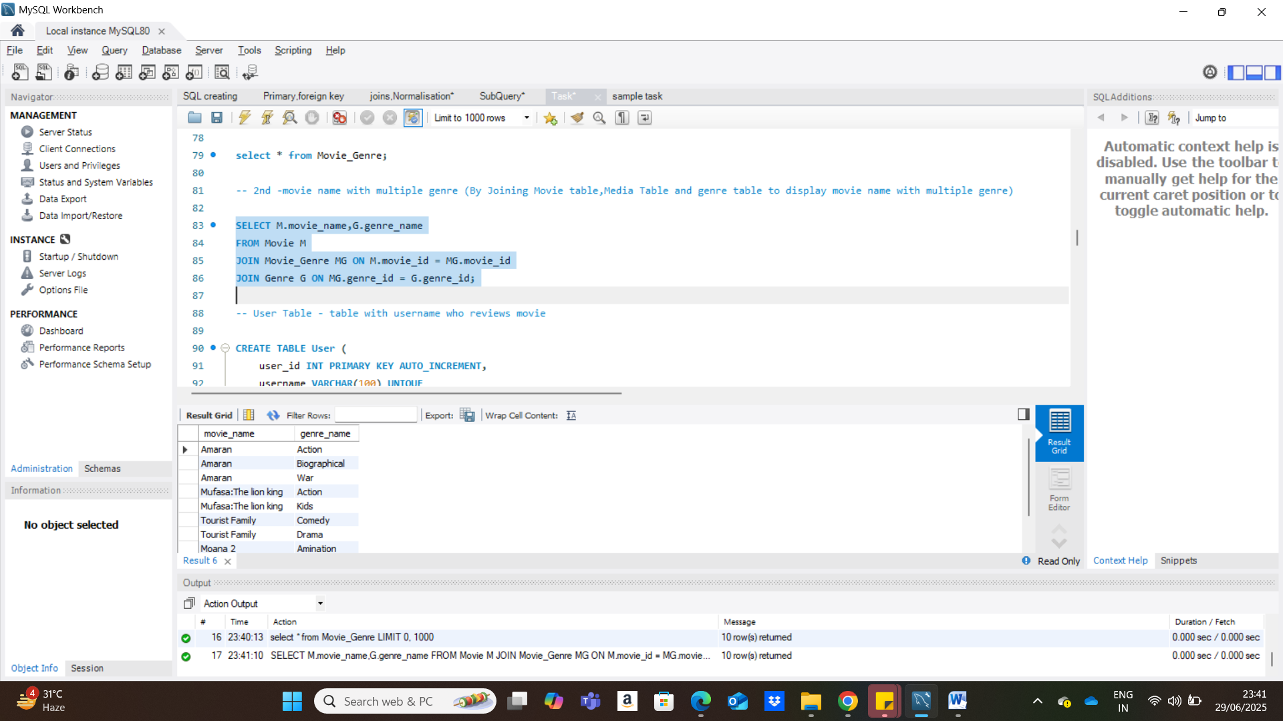

**After Grouping By Movie name**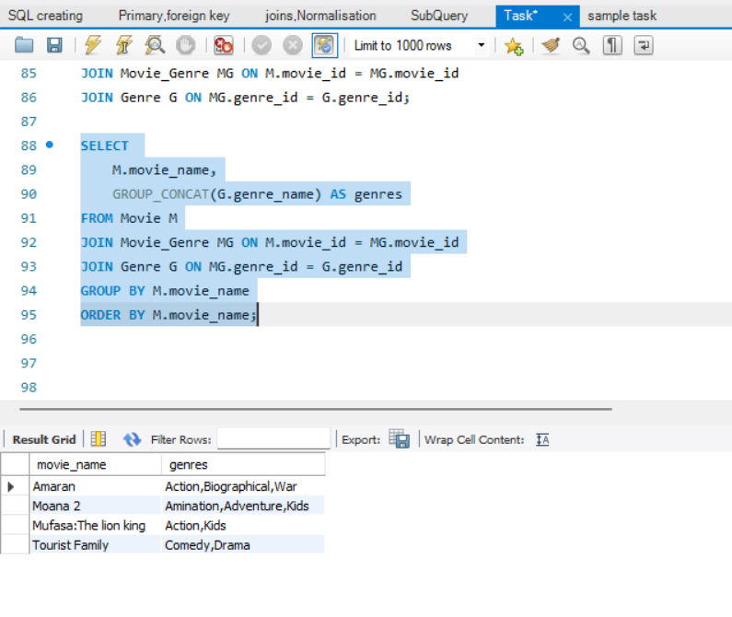

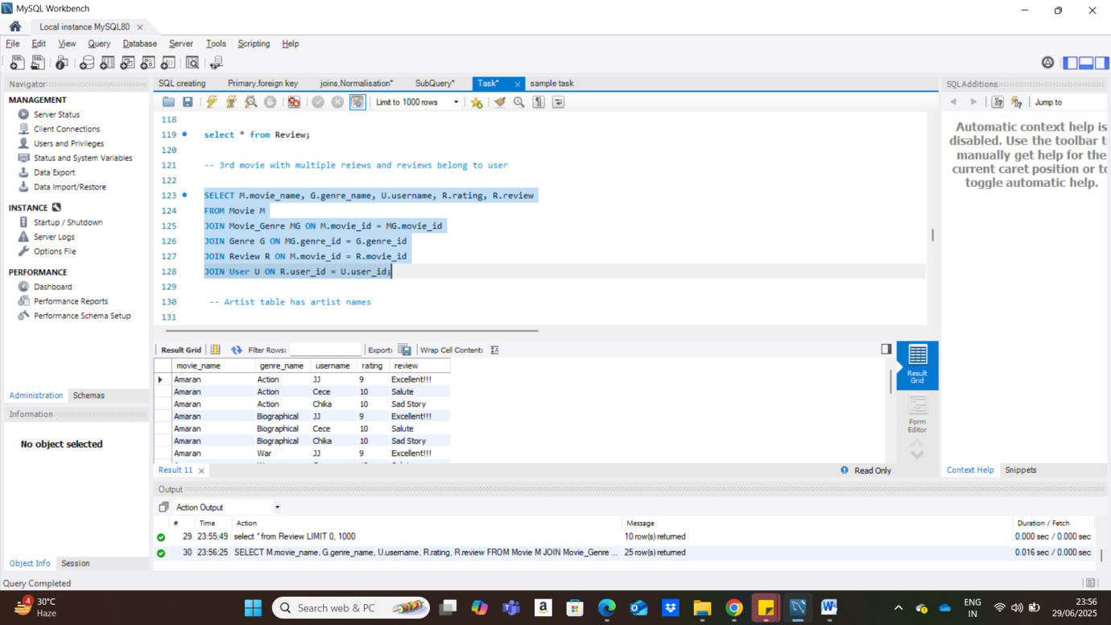**3)** **movie with multiple reiews and reviews belong to user**

**After Grouping**

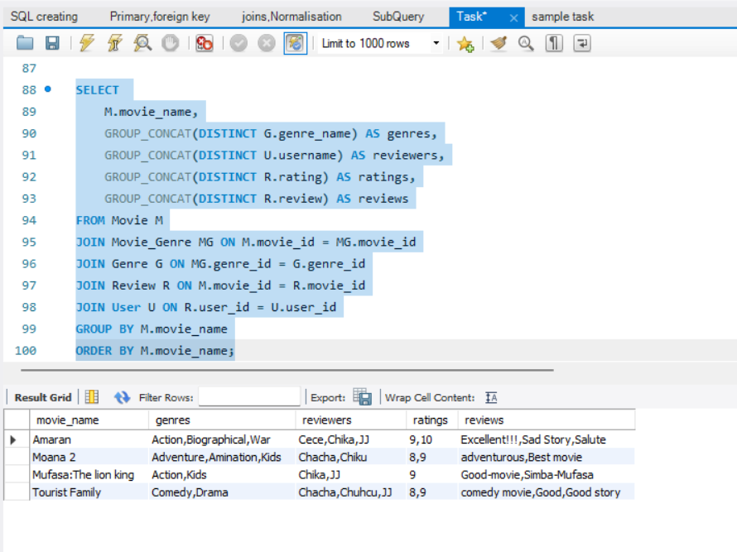

**4) Artist with multiple skills**

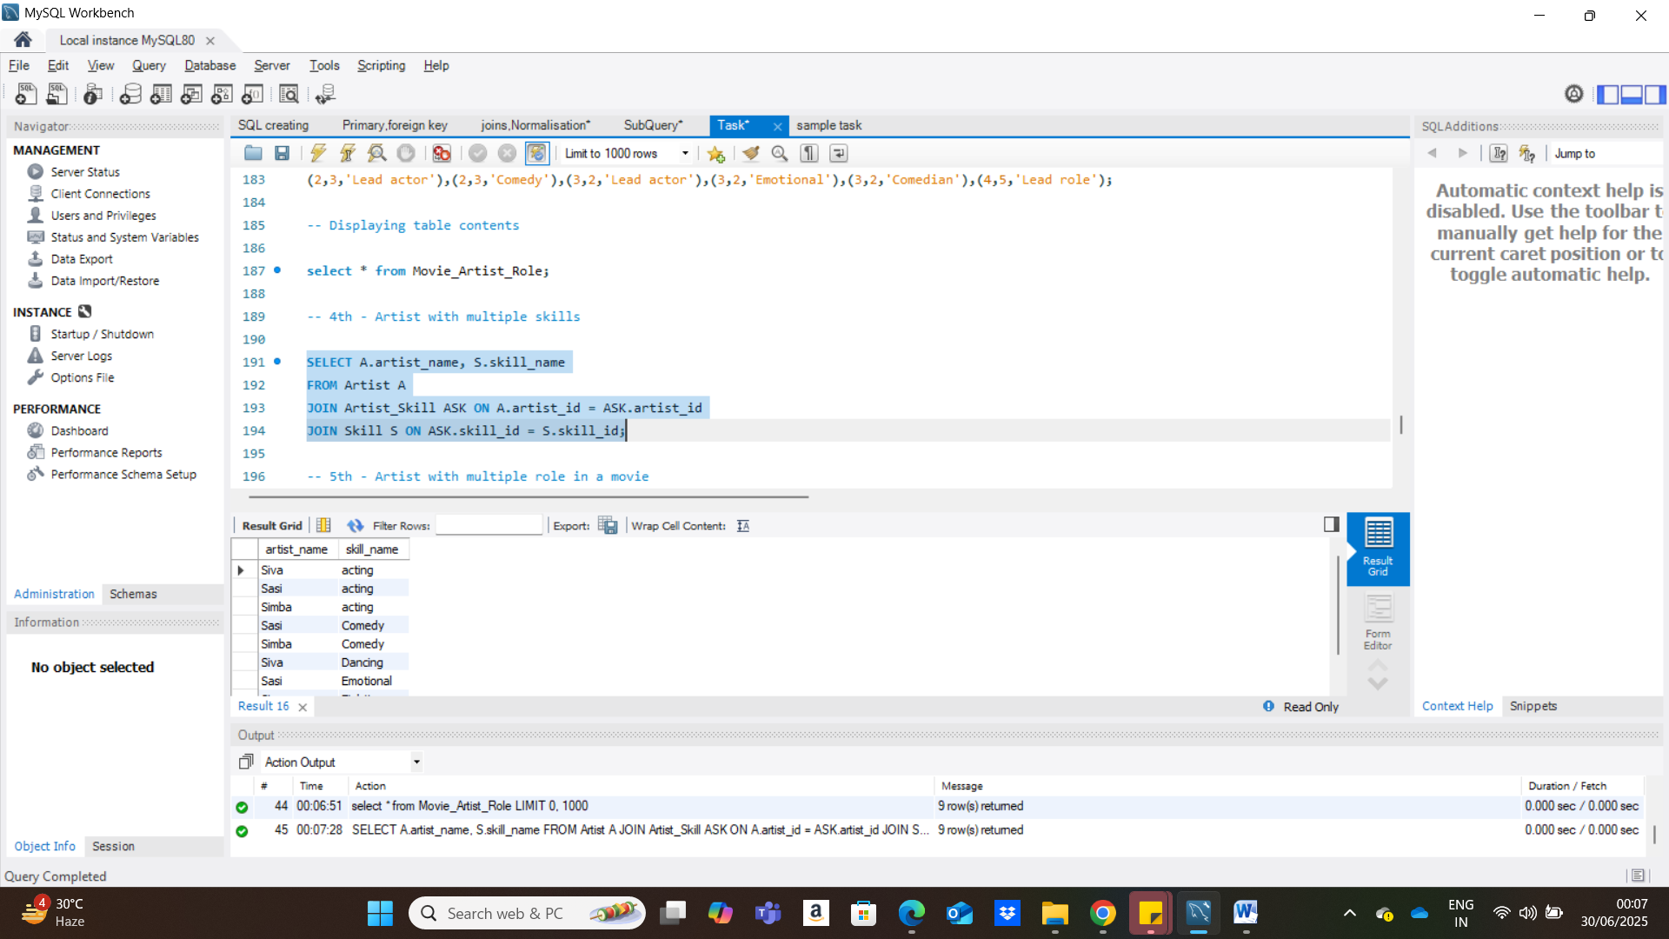

**After Grouping by Movie name**

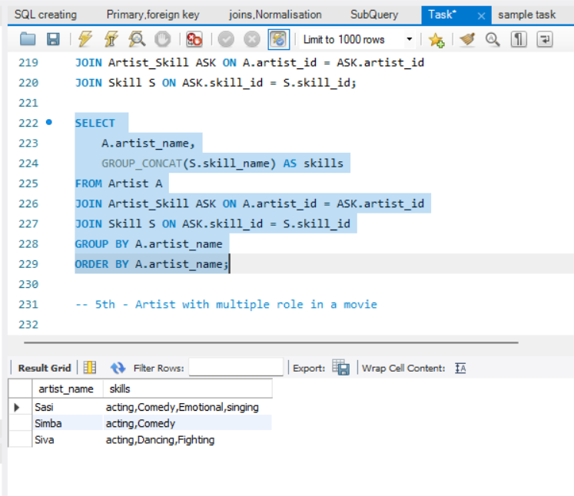

**5) Artist with multiple role in a movie**

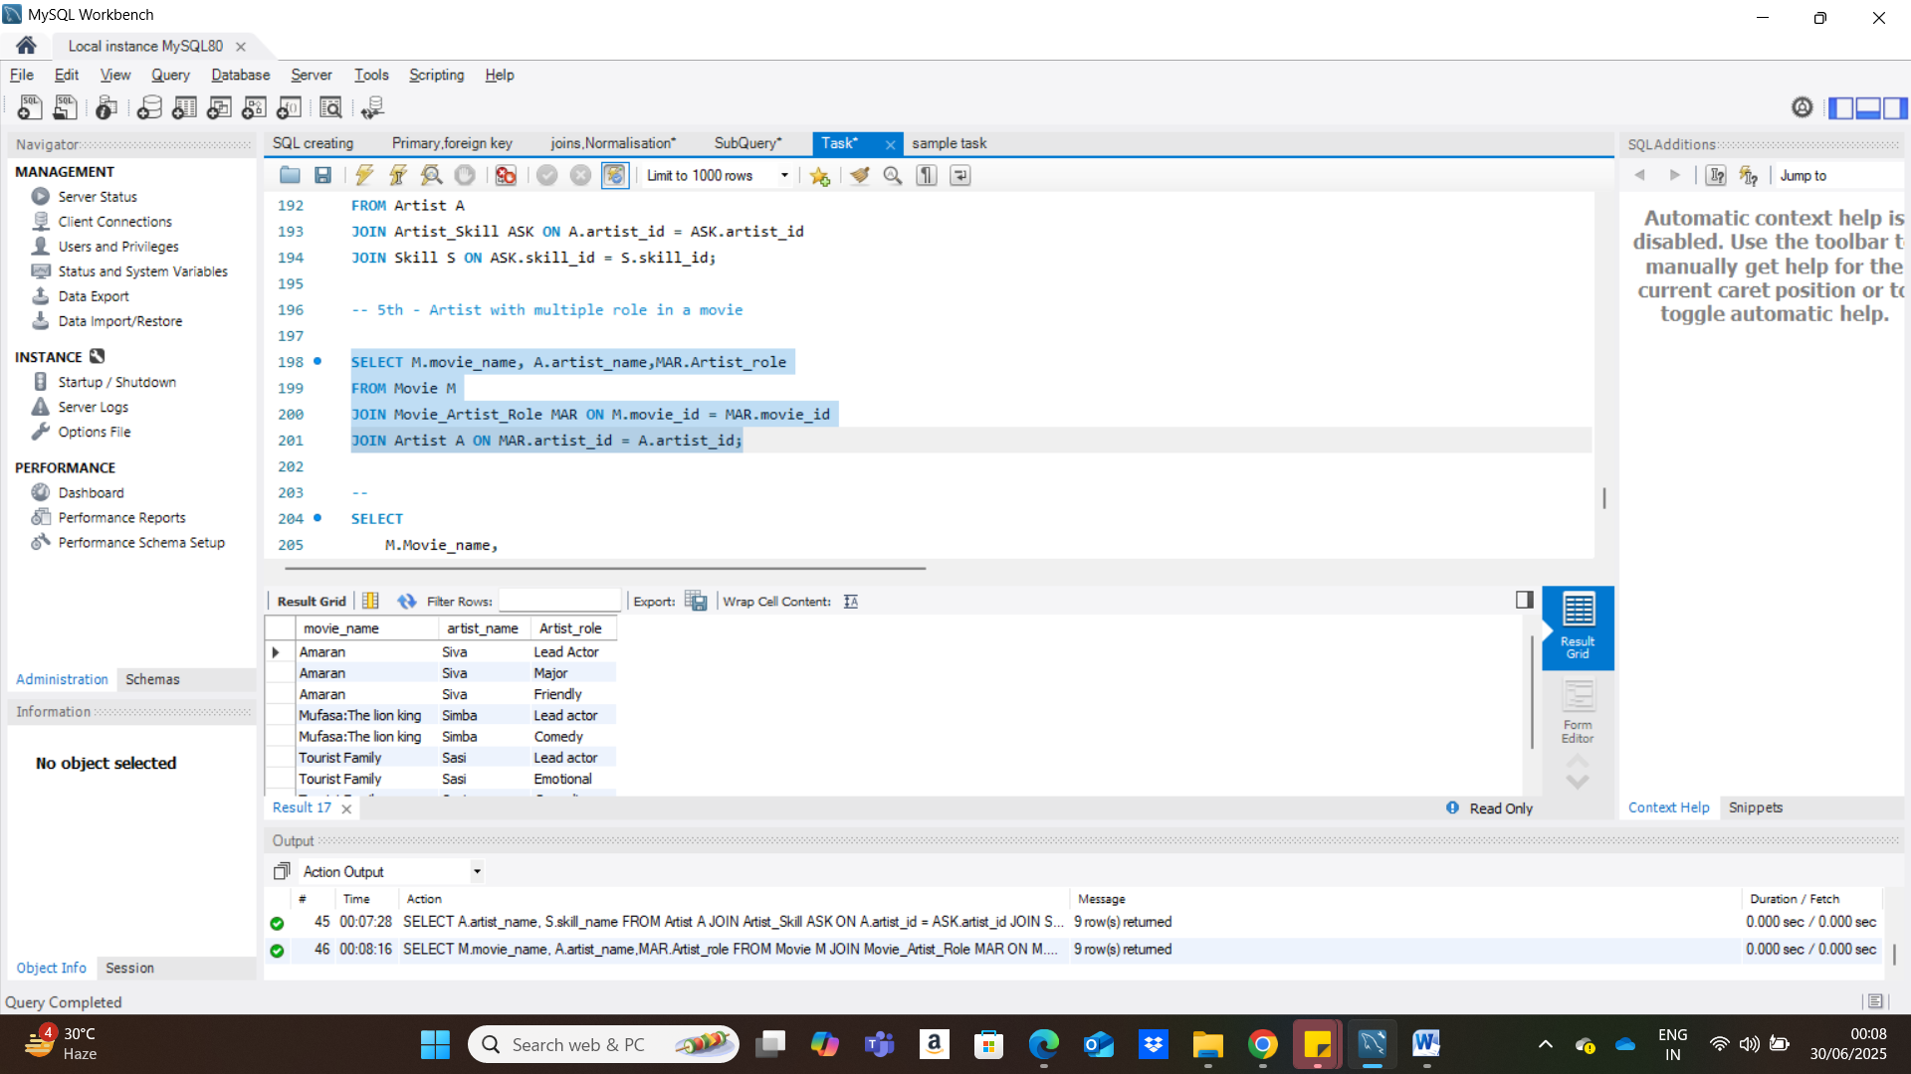

After Grouping by movie name

